
KPAD 4.0
10/13/2022

Using KPAD Cart Import in POS & ROM

KPAD users can now import their KPAD carts into NetView ECO Desktop programs in order to sell them to customers on a ticket in either Parts Point of Sale (POS) or Repair Order Maintenance (ROM). See below for instructions on how to use the cart import in both programs.

Using KPAD Cart Import in Point of Sale (POS):

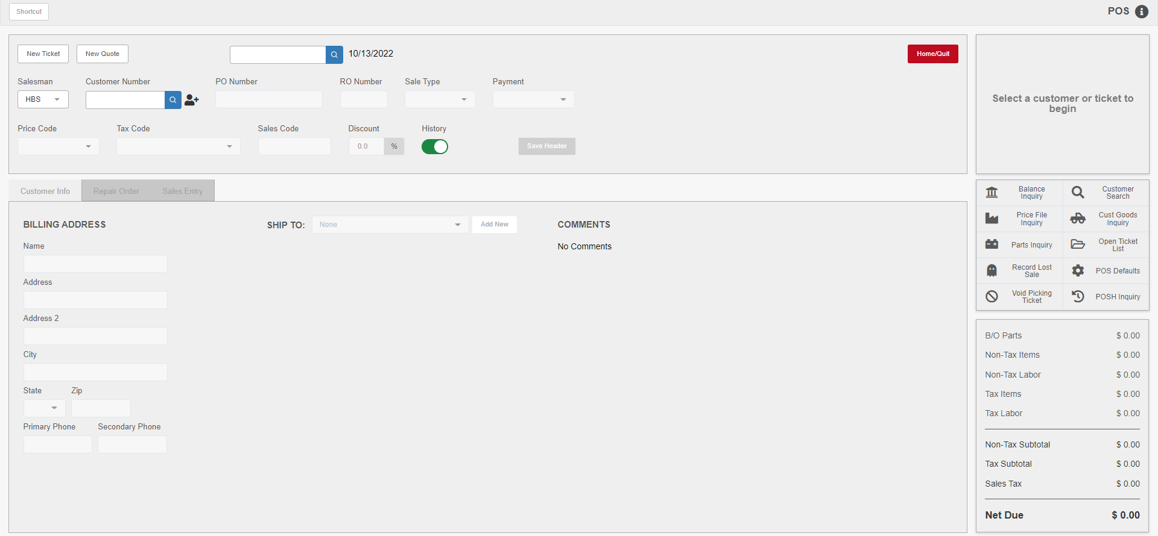

In Point of Sale (POS), create or open the ticket you want to import the cart onto, then navigate to the “Sales Entry” tab. NOTE: For the purpose of these instructions, the images will represent a new ticket with no parts already added.

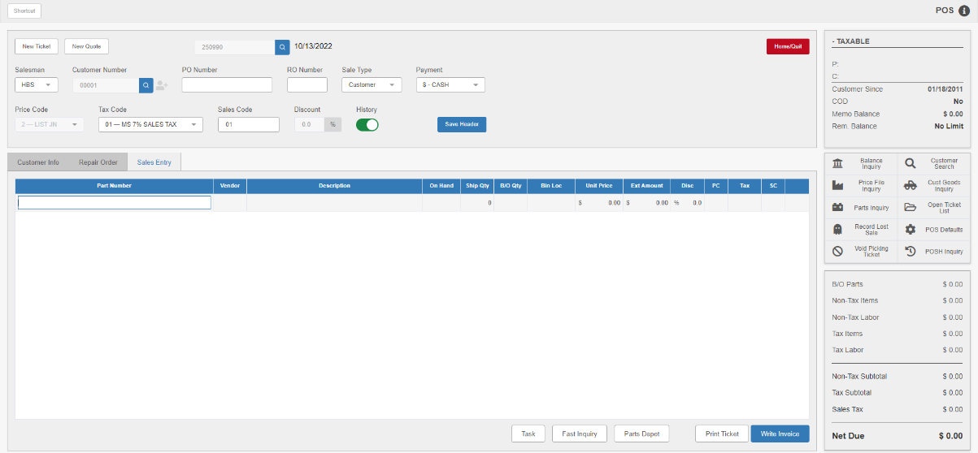
Enter a space and then the POS Line Task Code “EPC” in the “Part Number” column for the blank ticket line.

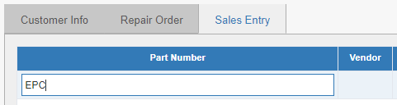

Click either the “Tab” or “Enter” key on the keyboard, or simply click outside the column. This will open the Cart Import window, which lists all carts for the entire location, not just those of the current user.

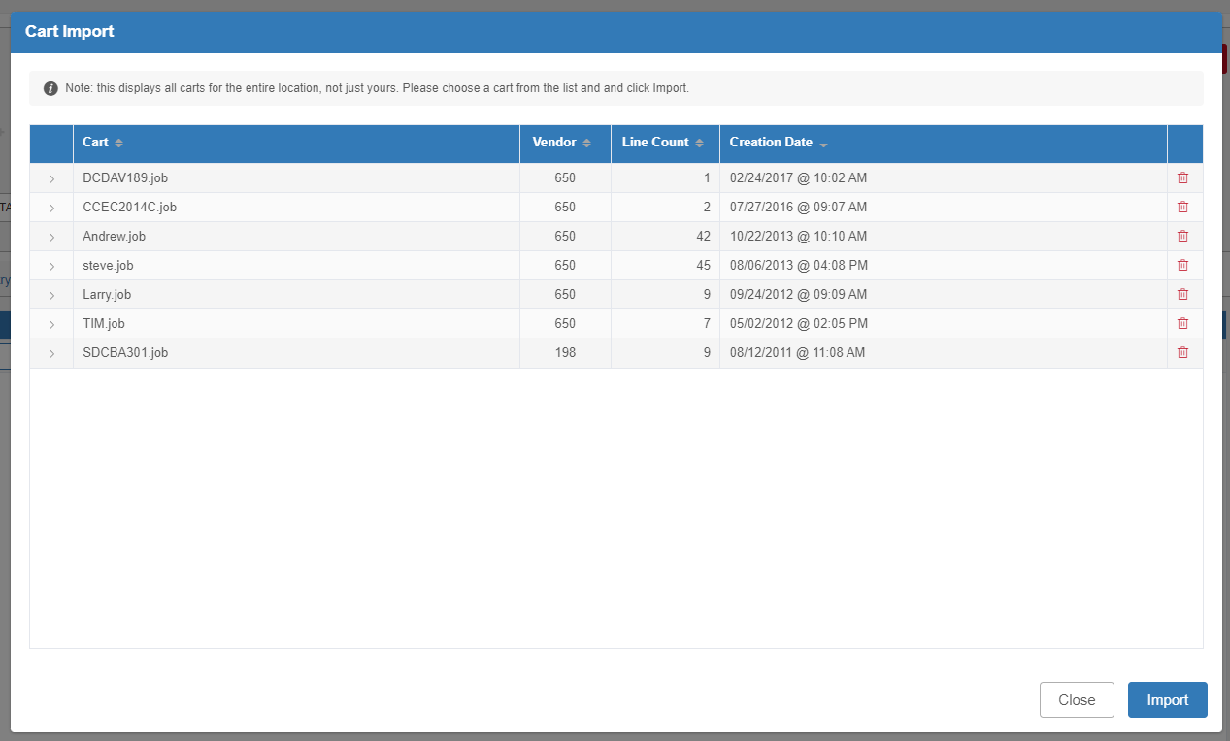

The window will automatically show each cart’s saved name, part vendor number, line count (i.e. how many parts are in the cart), and creation date. NOTE: You can also delete carts from this window using the trash can icon on the far right of the line, but we do not recommend this unless you as a user originally created the cart.

You can click the arrow to the left of the cart’s name to view more information about the individual parts contained in the cart:

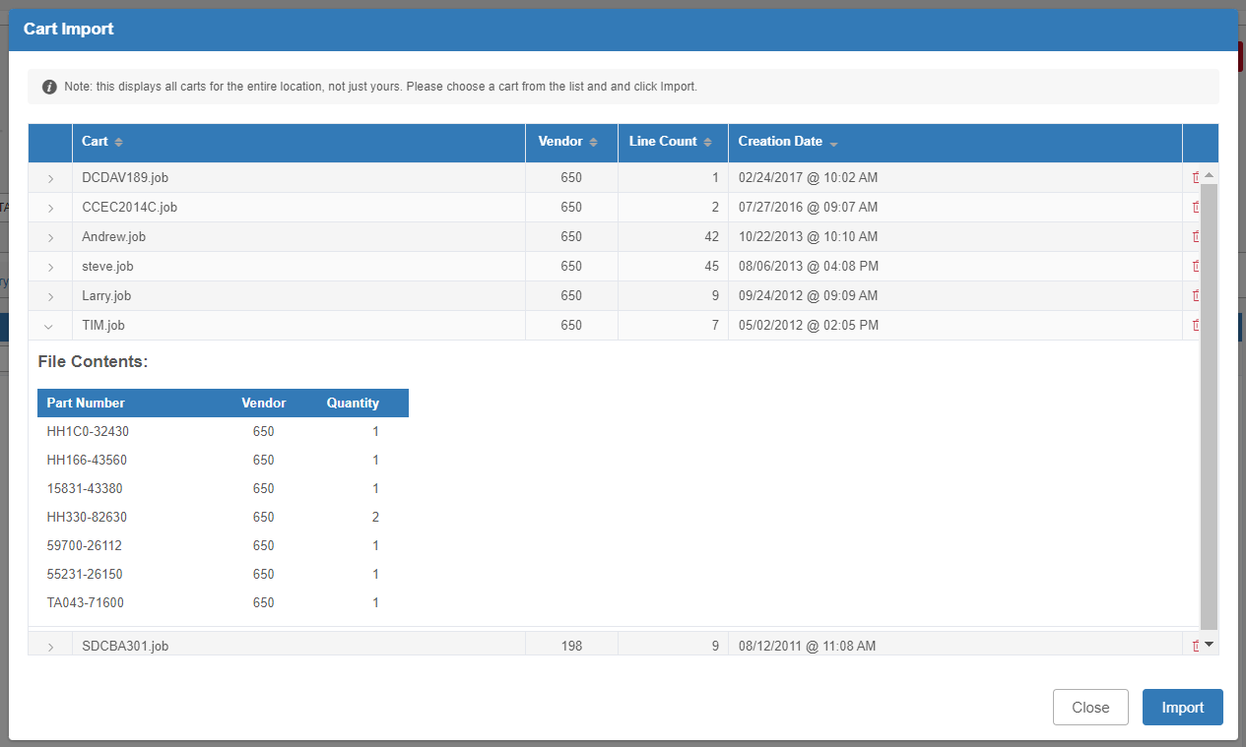

To import the cart’s contents onto the POS ticket, click on the cart you want to import so it highlights as in the image below. Then click the Import button.

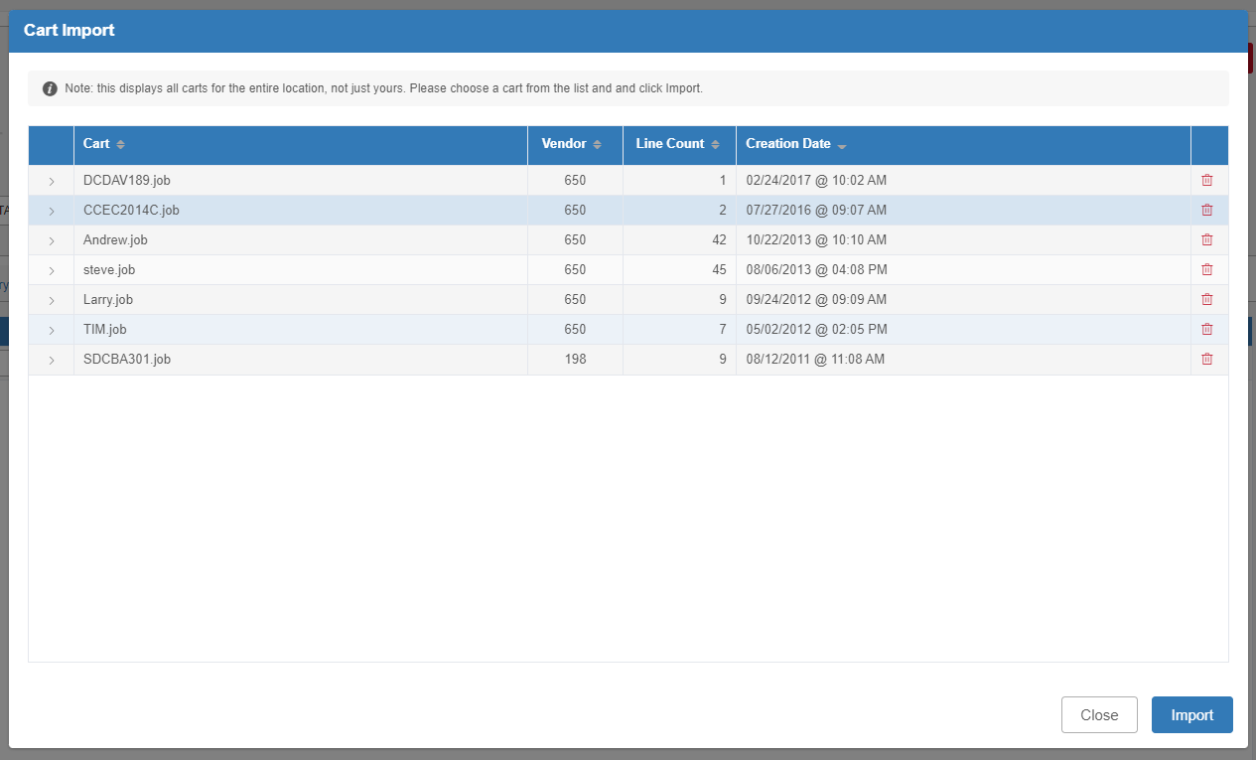

The window will close and the program will automatically insert all parts from the cart as lines on the ticket.

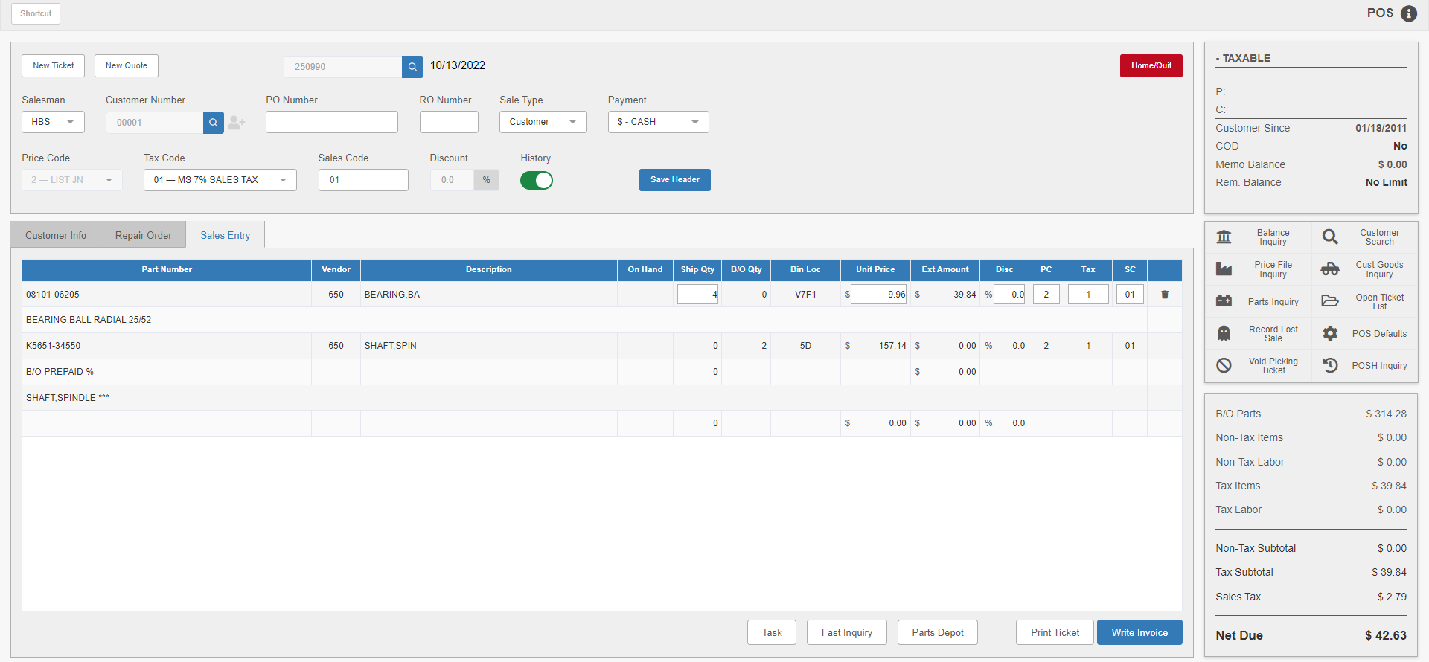

If any parts need to be backordered, the program will prompt for the backorder confirmation prior to importing the parts. In this case, modify the order number or other information as needed, then click Update to finish the import.

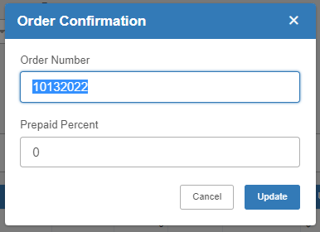

NOTE: Once you import a cart onto a POS ticket, it will no longer show in the Cart Import modal. Carts are removed from the list as soon as they are imported onto a ticket.

Using KPAD Cart Import in Repair Order Maintenance (ROM):

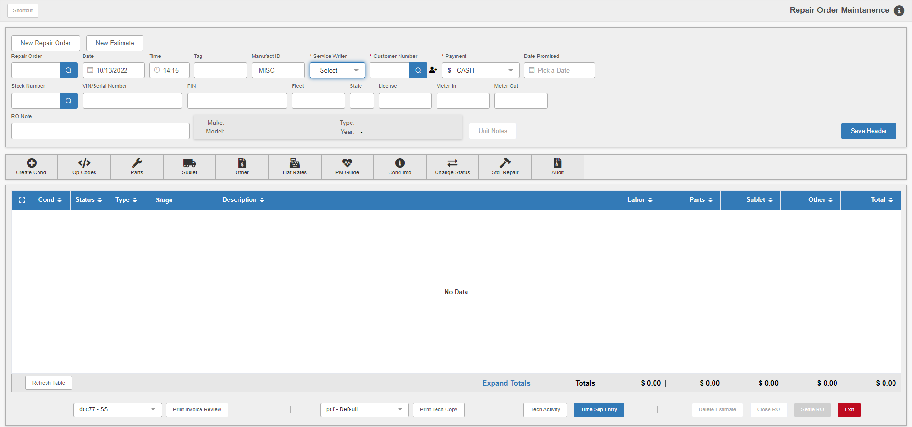

In Repair Order Maintenance, access the repair order and the specific condition that you want to import the cart on. NOTE: For the purpose of these instructions, the images will represent a condition with no parts already added.

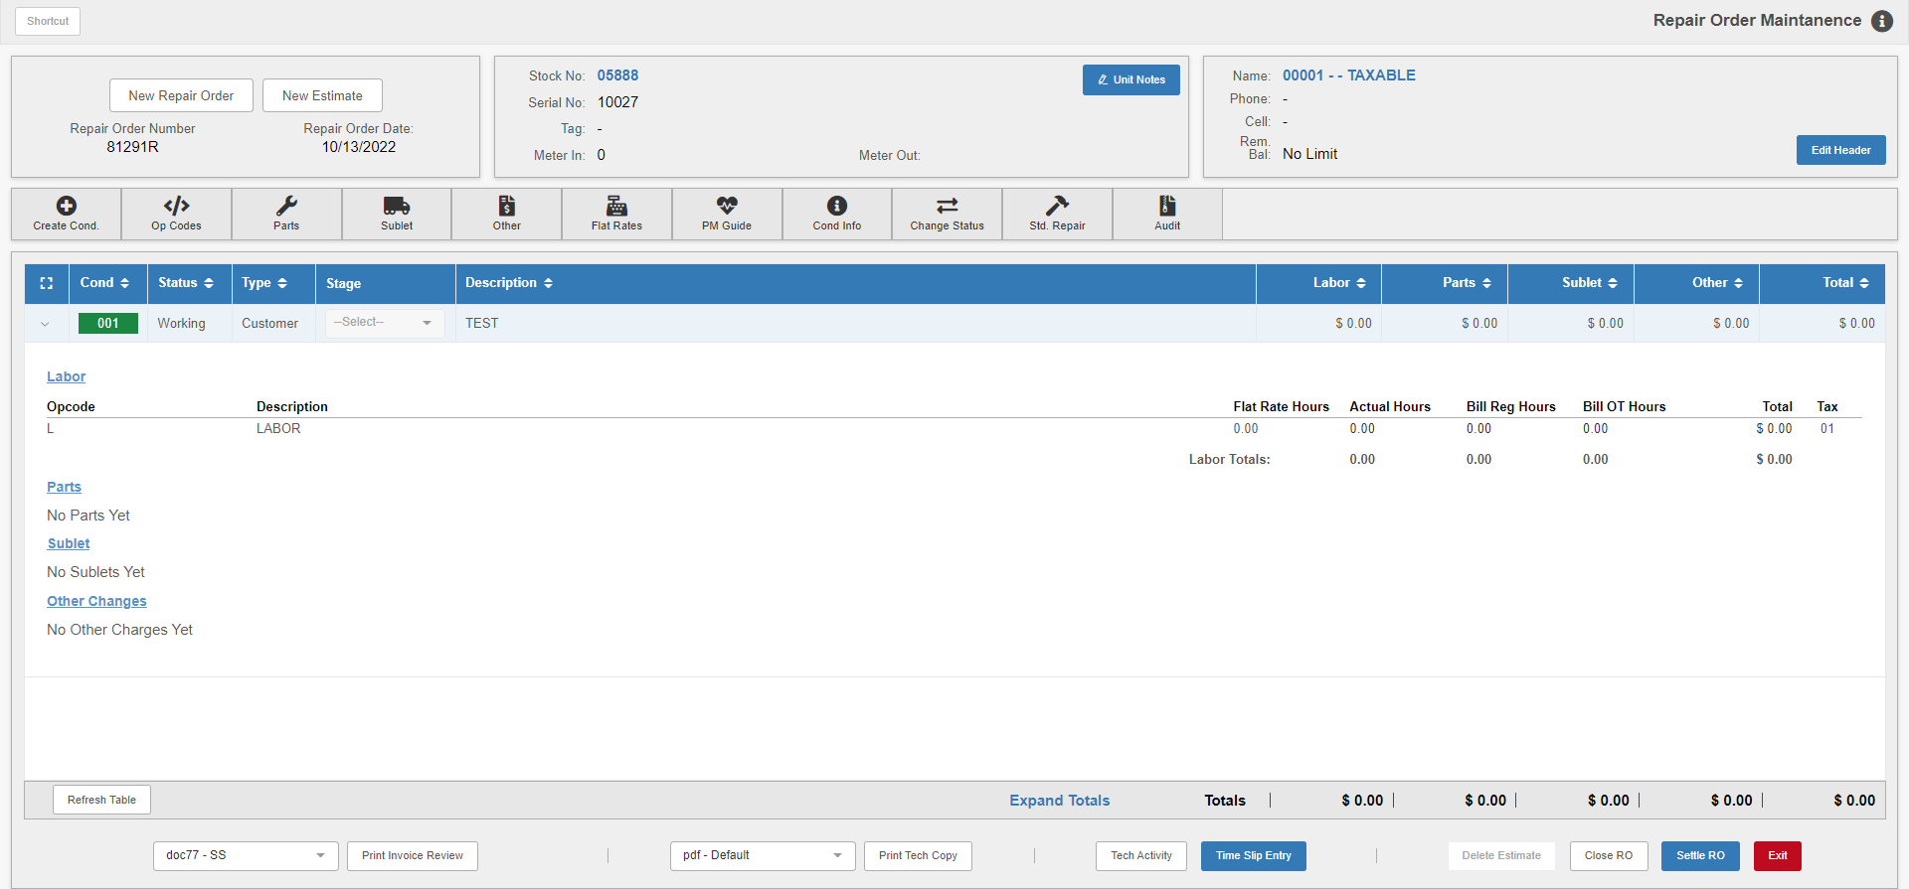

Click on “Parts” inside the expanded condition to open the Service Parts POS screen. From this point forward, the function operates identically to in POS. Enter a space and “EPC” in the next empty line on the ticket.

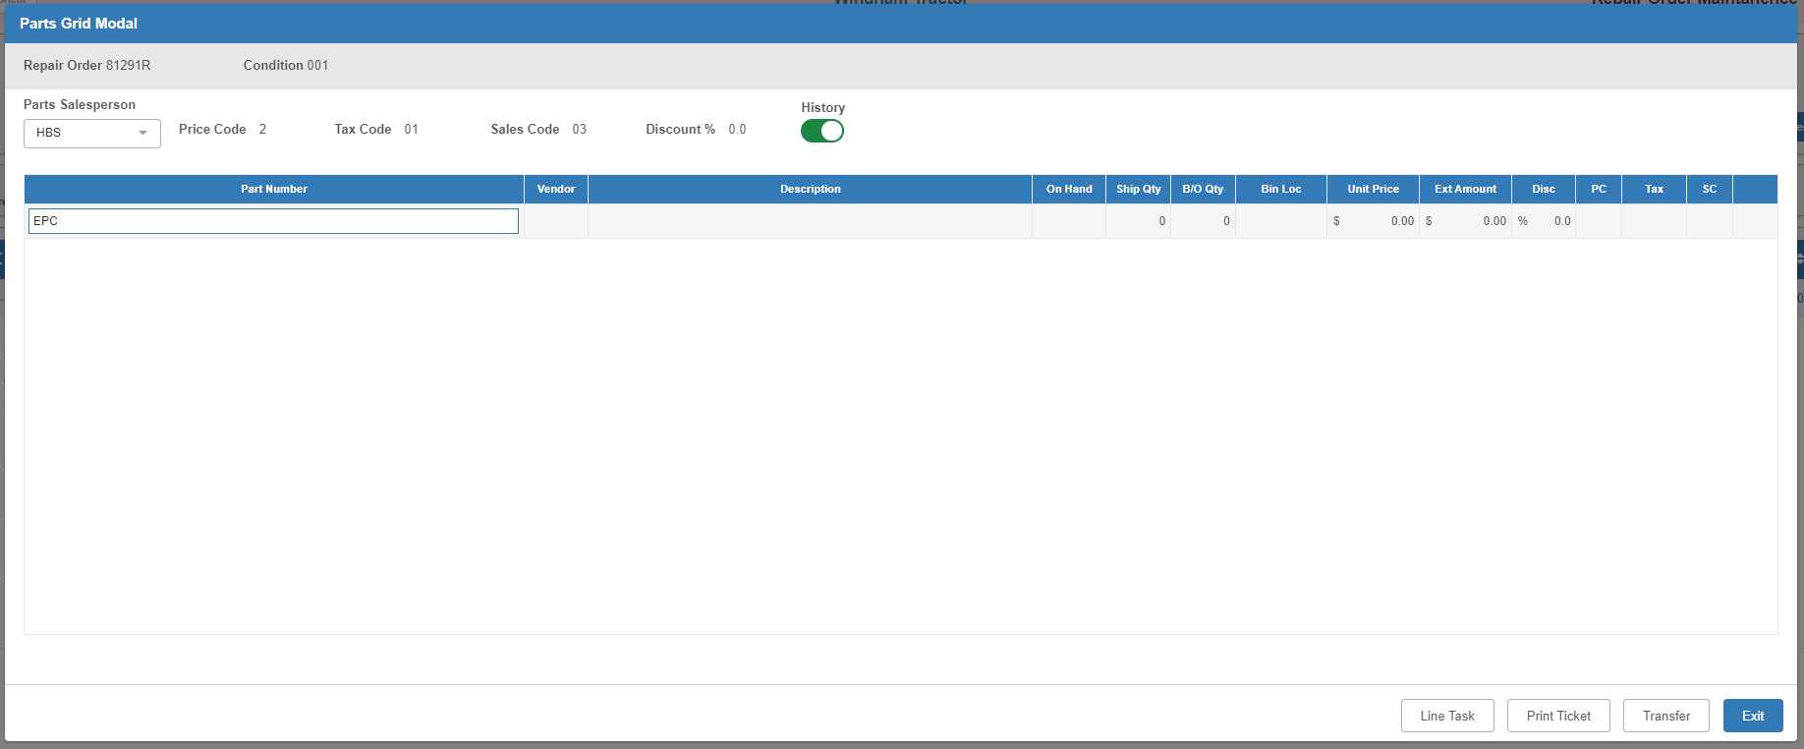

Click either the “Tab” or “Enter” key on the keyboard, or simply click outside the column. This will open the Cart Import window, which lists all carts for the entire location, not just those of the current user.



The window will automatically show each cart’s saved name, part vendor number, line count (i.e. how many parts are in the cart), and creation date. NOTE: You can also delete carts from this window using the trash can icon on the far right of the line, but we do not recommend this unless you as a user originally created the cart.

You can click the arrow to the left of the cart’s name to view more information about the individual parts contained in the cart:



To import the cart’s contents onto the POS ticket, click on the cart you want to import so it highlights as in the image below. Then click the Import button.


The window will close and the program will automatically insert all parts from the cart as lines on the ticket.

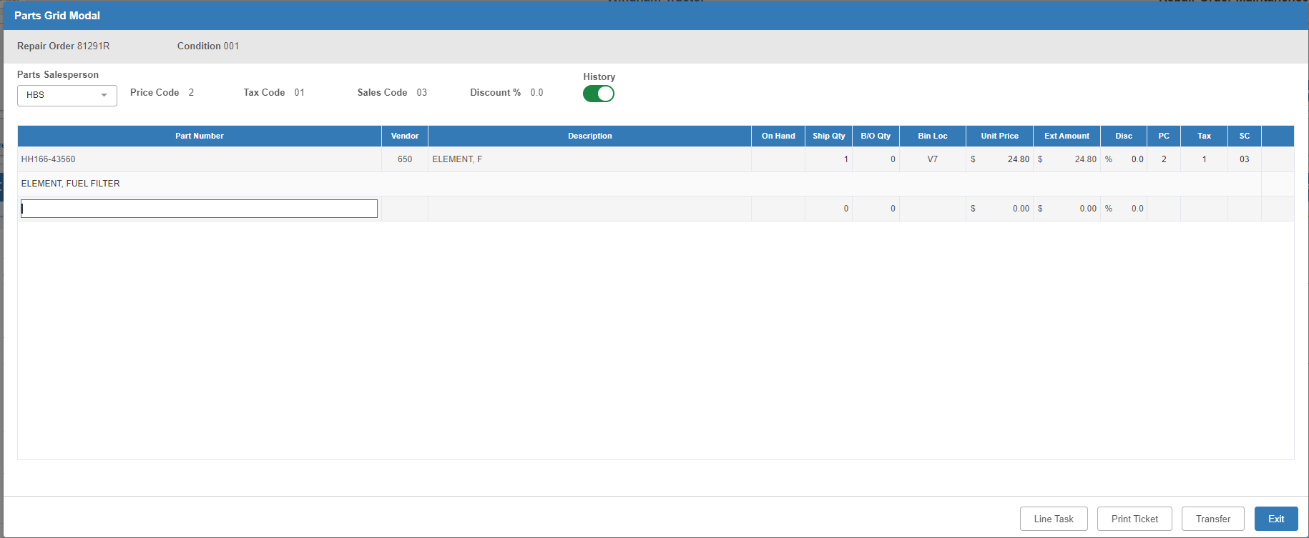

If any parts need to be backordered, the program will prompt for the backorder confirmation prior to importing the parts. In this case, modify the order number or other information as needed, then click Update to finish the import.



NOTE: Once you import a cart onto a POS ticket, it will no longer show in the Cart Import modal. Carts are removed from the list as soon as they are imported onto a ticket.

When you exit the Service Parts POS screen, the imported parts will now appear on the condition.

